Supporting Information

Modulating Static and Dynamic Magnetizations of Ytterbium(III) Coordination Polymers by Light-Induced Radicals
Xiaoshuang Gou¹, Yuewei Wu¹, Hanqi Wen², Liang Li¹, Wenlong Lan¹, Ning Liu¹, Shiqi Zhang¹, Liviu Ungur²*, Peng Cheng¹* and Wei Shi¹*
1 Frontiers Science Center for New Organic Matter, Key Laboratory of Advanced Energy Materials Chemistry (MOE) and State Key Laboratory of Advanced Chemical Power Sources, College of Chemistry, Nankai University, Tianjin 300071
2 Department of Chemistry, National University of Singapore, 3 Science Drive 3, Singapore 117543
*Corresponding Author(s): chmlu@nus.edu.sg, pcheng@nankai.edu.cn, shiwei@nankai.edu.cn

Table of Contents
1. Experimental section……………………………………………………………………………S1
2. Figures……………………………………………………………………………………………S3
3. Tables……………………………………………………………………………………………S22
4. References………………………………………………………………………………………S33

Experimental section
Materials. All chemicals and solvents were commercially available and used as received. 2,5-Dichloro-3,6-dihydroxy-p-quinone (H₂CA, 98%, Tokyo Chemical Industry Development Co., LTD), ytterbium chloride hexahydrate (YbCl₃·6H₂O, 98.75%, Shanghai Hao Hong biological medicine Technology Co., LTD), 9-Anthracenecarboxylic acid (HACA, 98%, Bide Pharmatech LTD.), N,N-Dimethylformamide (DMF, AR, Tianjin Concord Technology Co. LTD).
Physical measurements. Elemental analyses (EA) for C, H and N were performed on a Vario EL CUBE elemental analyzer. Fourier transform infrared (FTIR) spectra were recorded with a Bruker ALPHA FTIR spectrophotometer equipped with an attenuated total reflectance accessory in the range 400–4000 cm⁻¹. Powder X-ray diffraction (PXRD) measurements were carried out on a Rigaku Smartlab SE X-ray diffractometer using Mo-Kα radiation. Thermogravimetric analyses (TGA) were performed on a Mettler Toledo TGA 2 thermal analyzer in the range 40–800 °C (heating rate = 5 °C/min) under N₂ atmosphere. UV-vis absorption spectra were recorded with a Shimadzu UV-2600 spectrophotometer. Electron paramagnetic resonance (EPR) spectra were respectively collected at room temperature using a Bruker E580-10/12 EPR spectrometer. Static (direct current, dc) magnetic susceptibility measurements were performed on a Quantum Design SQUID (MPMS) VSM magnetometer and corrected by the sample holder contribution and diamagnetic contributions estimated using Pascal’s constants.¹ Dynamic (alternating current, ac) magnetic susceptibilities were performed on a Quantum Design SQUID (MPMS) VSM or a PPMS magnetometer.

X-ray Structure Determination. Single crystal of 1 suitable for X-ray analysis was coated with Parabar oil and mounted on a MicroMounts rod. The crystallographic data were collected at 298(2) K on a Rigaku XtaLAB Mini II single-crystal diffractometer using graphite-monochromatic Mo-Kα radiation (λ = 0.71073 Å). The structure of 1 was solved by the direct methods with SHELXS and refined by full-matrix least-squares techniques against F² using the program package Olex2 version 1.5.² Anisotropic thermal parameters were used for the non-hydrogen atoms. Hydrogen atoms were added geometrically and refined by using a riding model. The parameters, data collection, and refinements of 1 are summarized in Table S1. The structure has been deposited at Cambridge Crystallographic Data Centre (CCDC number 2170113).

Figure S1. IR spectra for H₂CA, HACA, 1, 1a, 1@Y and 1a@Y.

Figure S2. Experimental and simulated PXRD patterns for 1, 1a, 1@Y and 1a@Y.

Figure S3. Thermogravimetric analysis of 1 under N₂ atmosphere (heating rate = 5 °C/min).

Figure S4. Thermogravimetric analysis of 1@Y under N₂ atmosphere (heating rate = 5 °C/min).

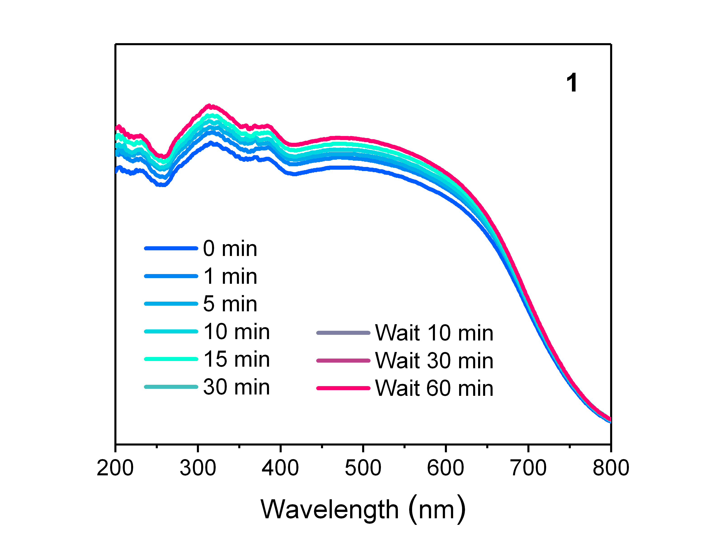
Figure S5. Time-dependent UV-vis spectra of 1 upon light irradiation.

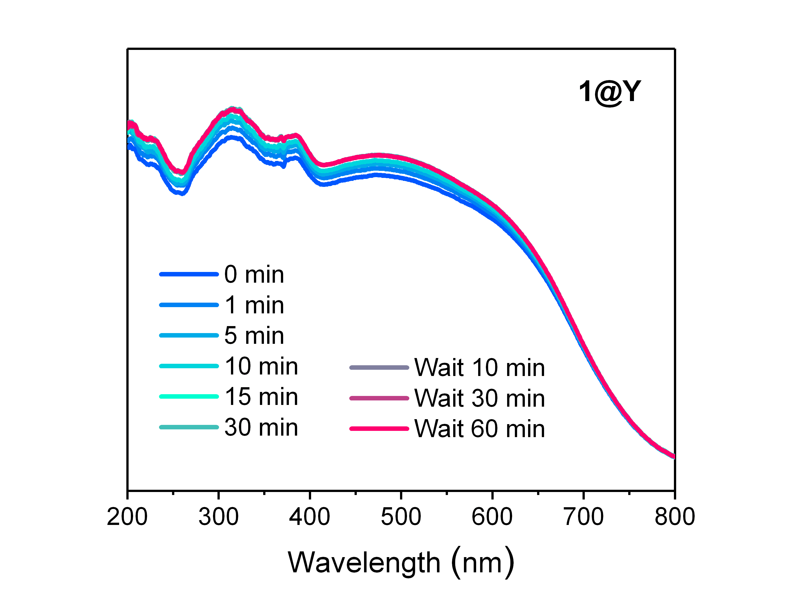
Figure S6. Time-dependent UV-vis spectra of 1@Y upon light irradiation.

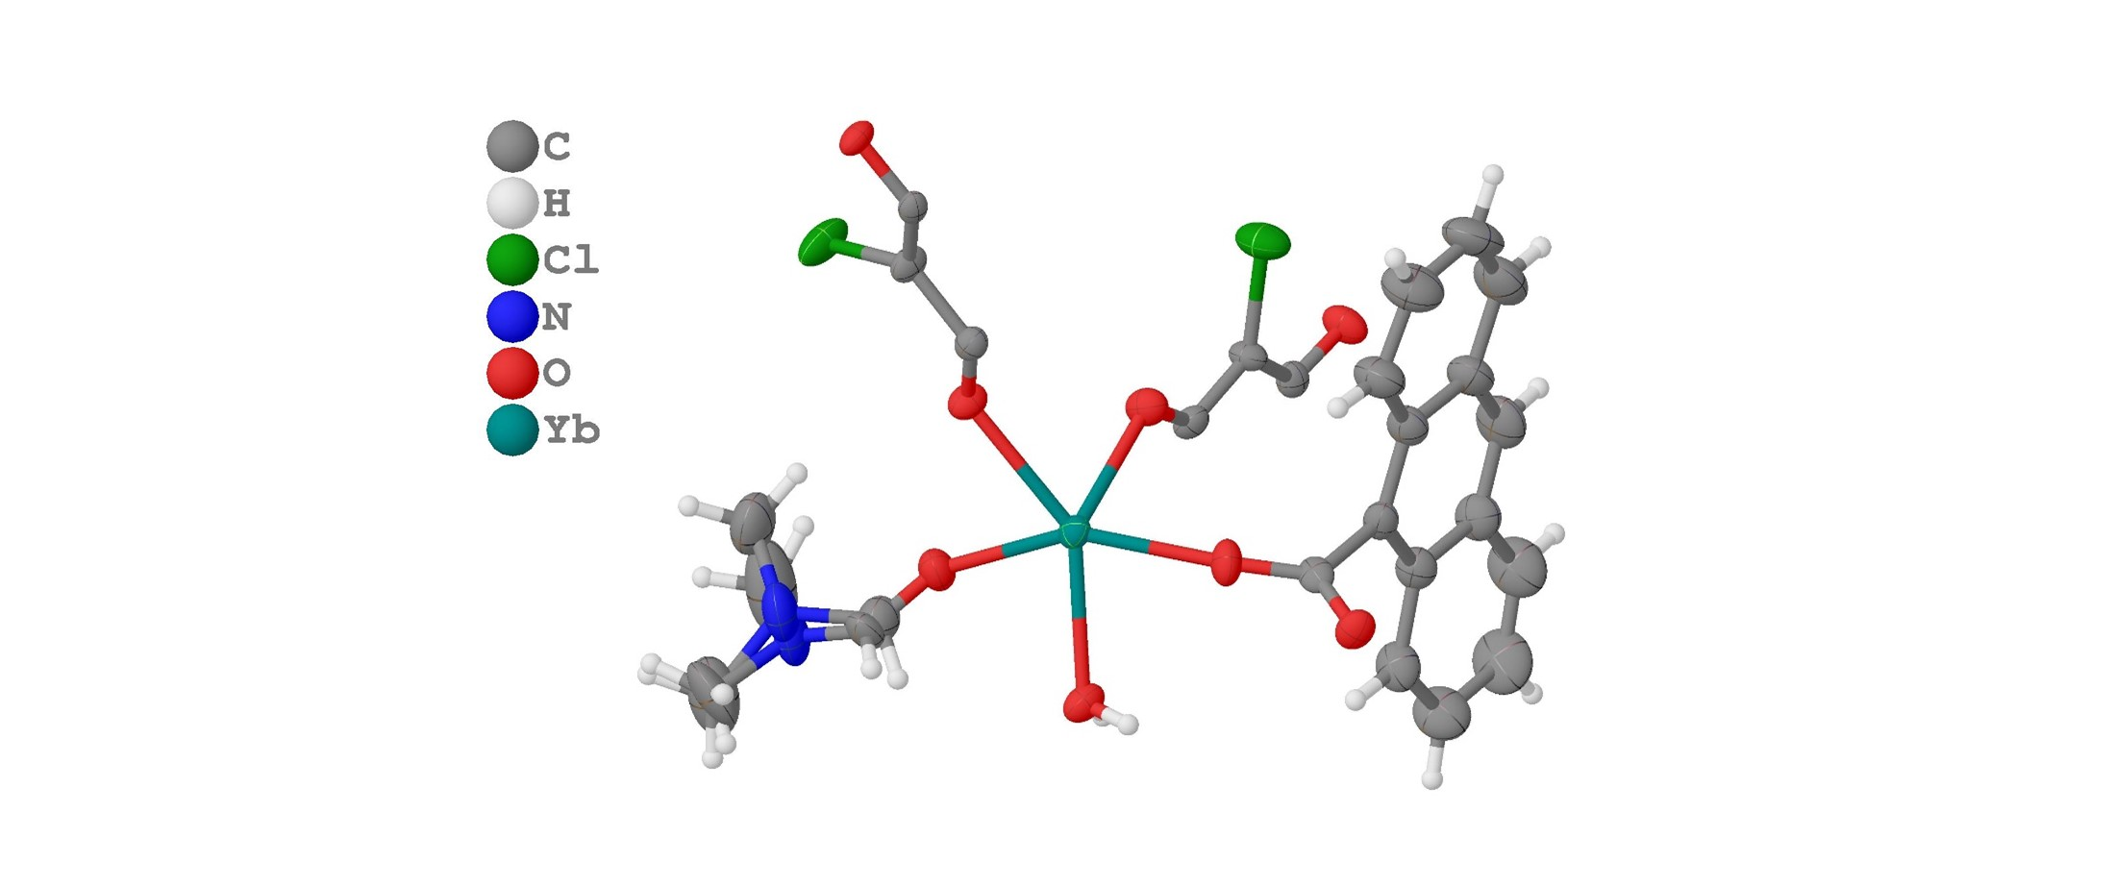
Figure S7. The asymmetric unit of 1 showing atomic displacement parameters (ADPs).

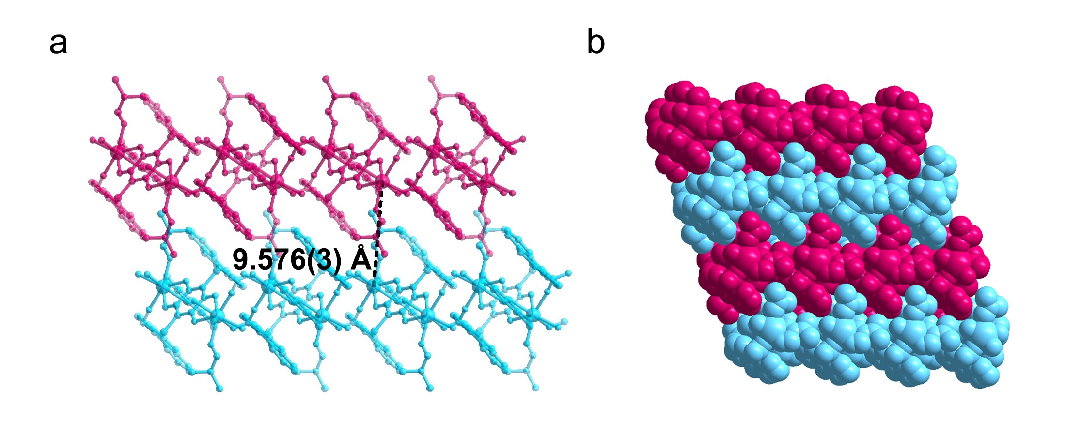
Figure S8. The shortest Yb···Yb distance between neighboring layers (a), and space filling model (b) of 1.

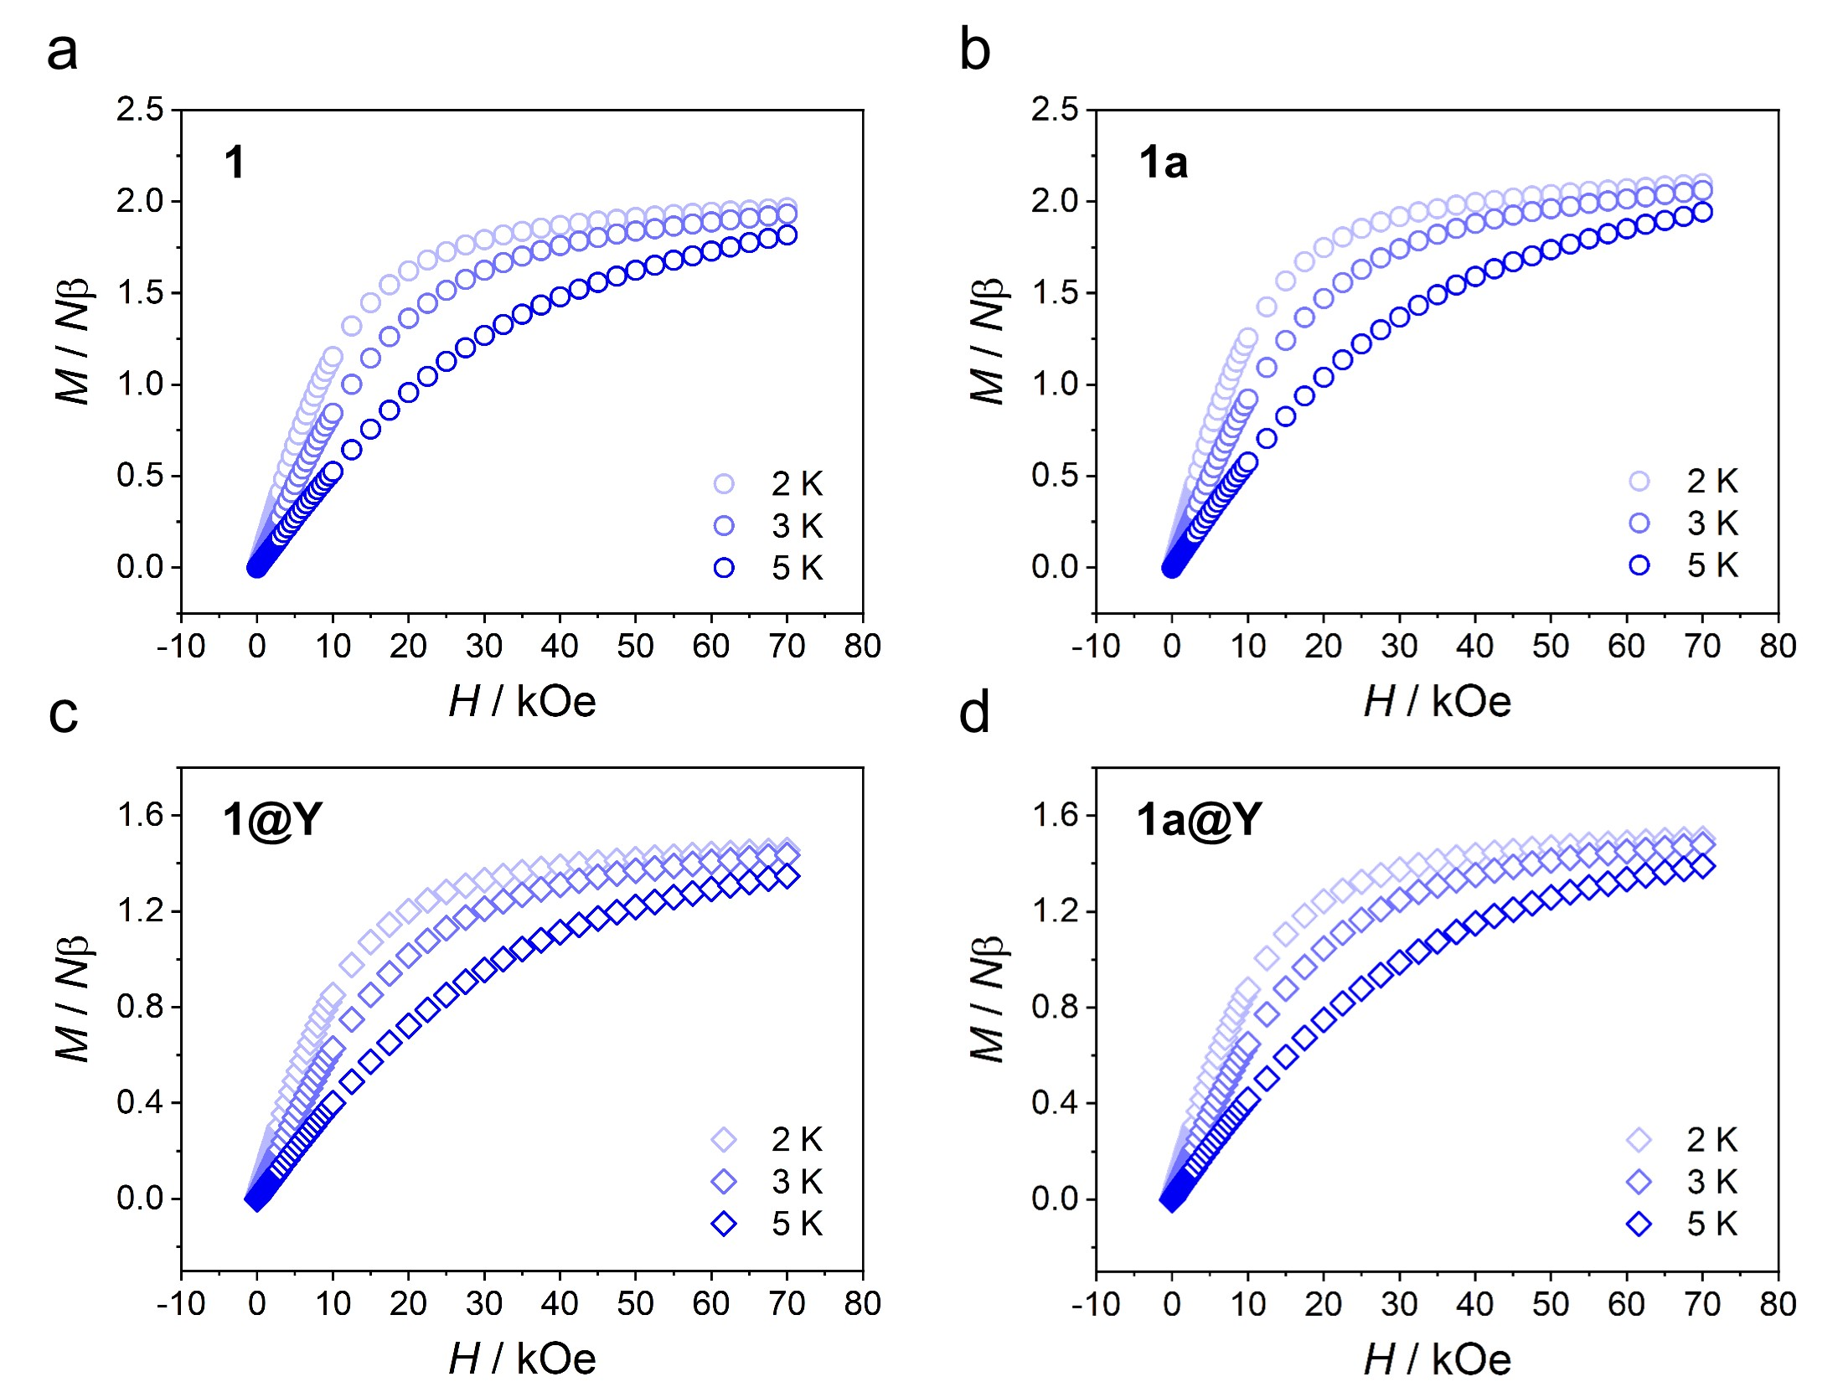
Figure S9. Variable field magnetizations of 1, 1a, 1@Y and 1a@Y at 2, 3 and 5 K.

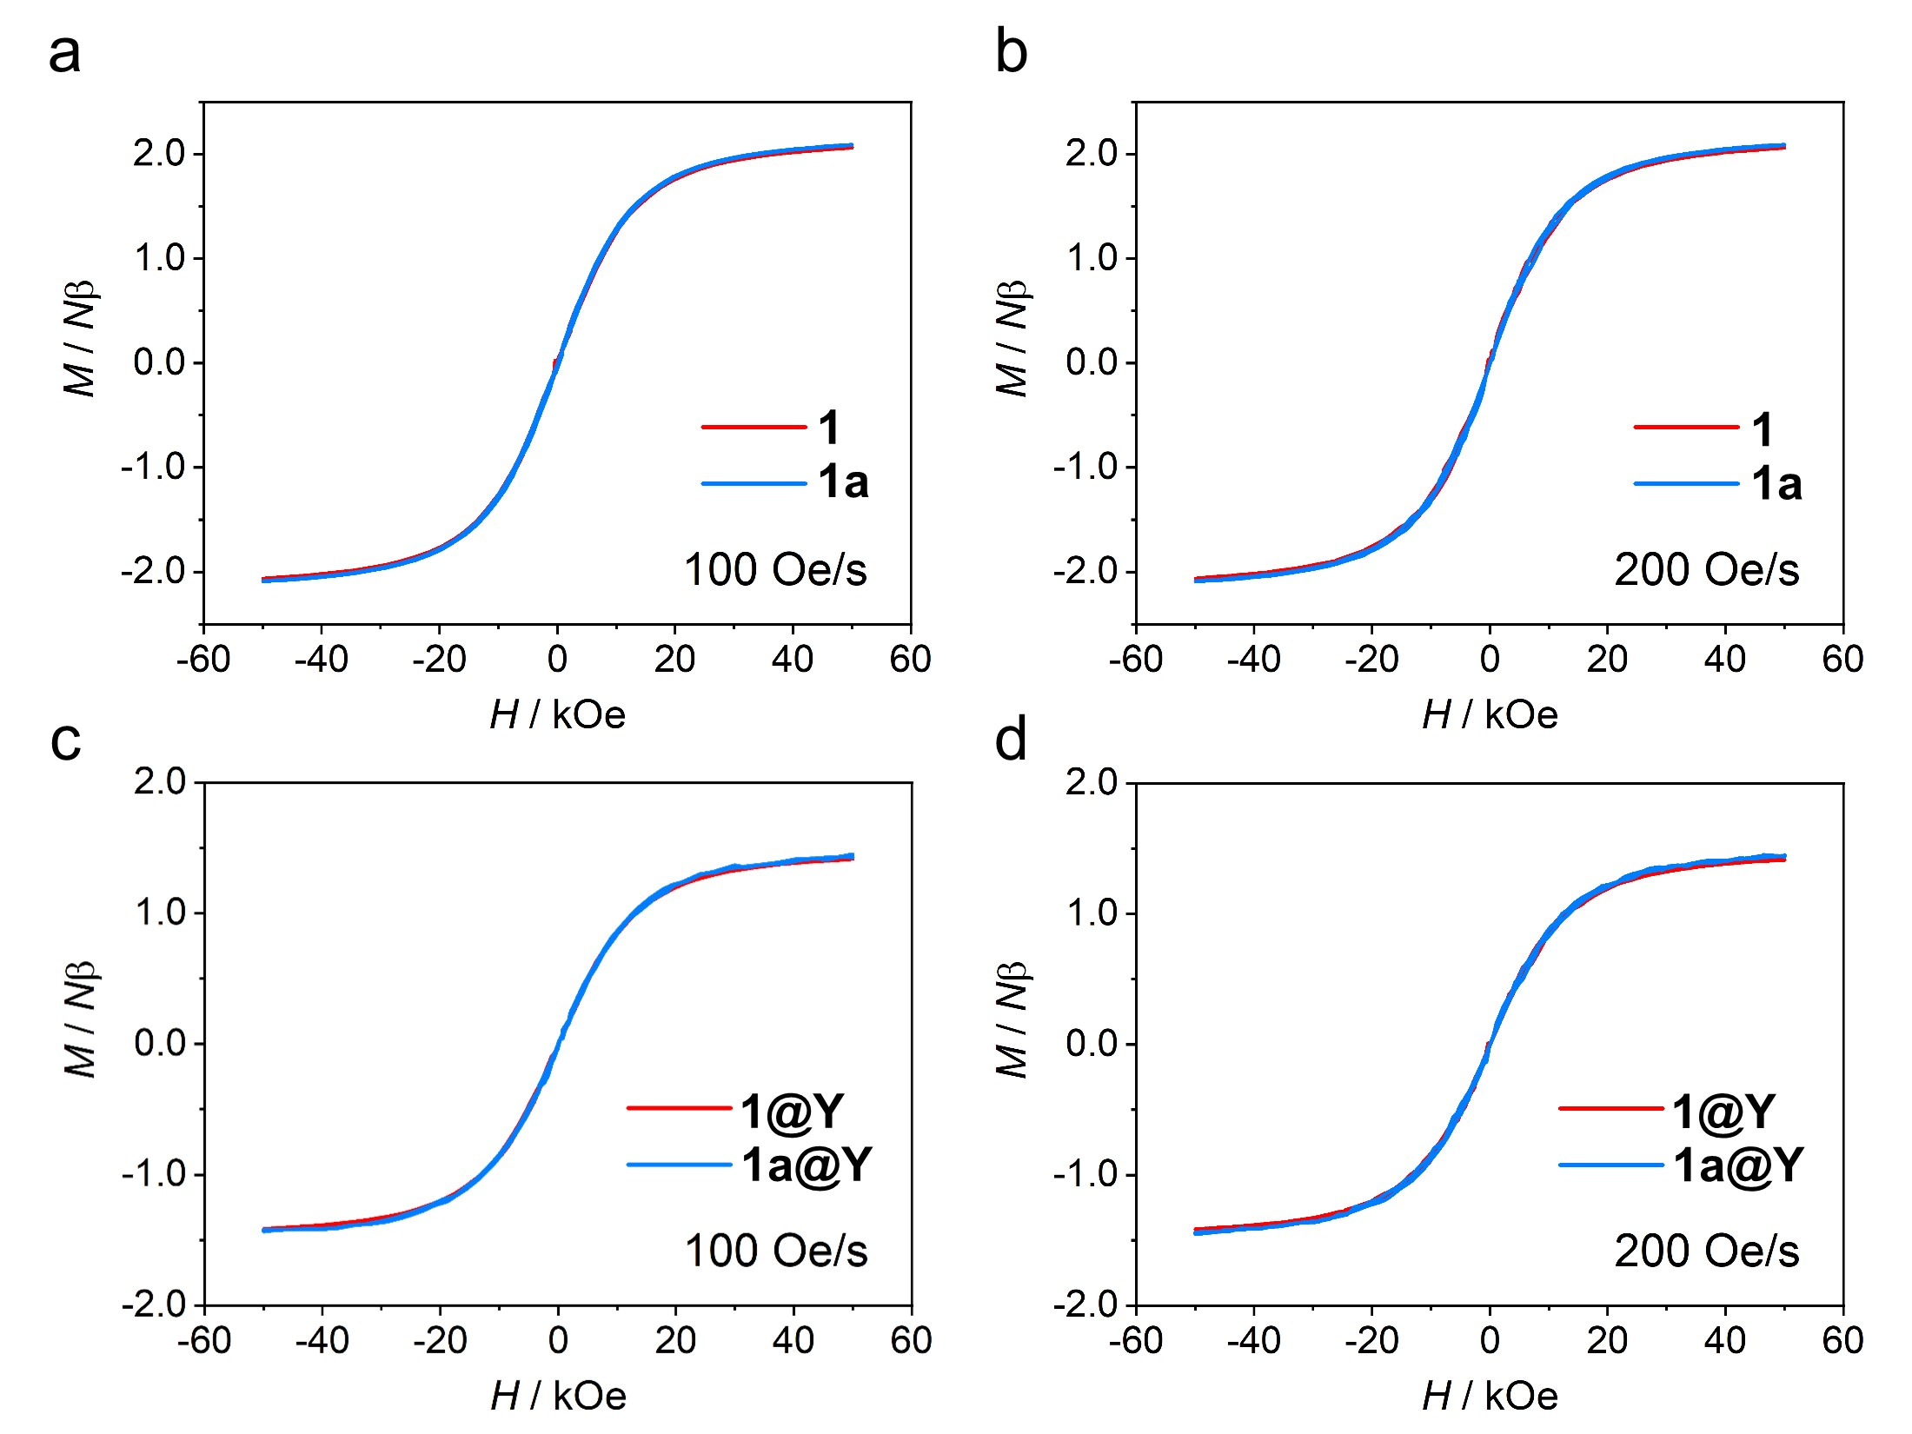
Figure S10. Magnetic hysteresis loops of 1, 1a (a, b), 1@Y and 1a@Y (c, d) at 2 K with field sweep rates of 100 and 200 Oe s⁻¹.

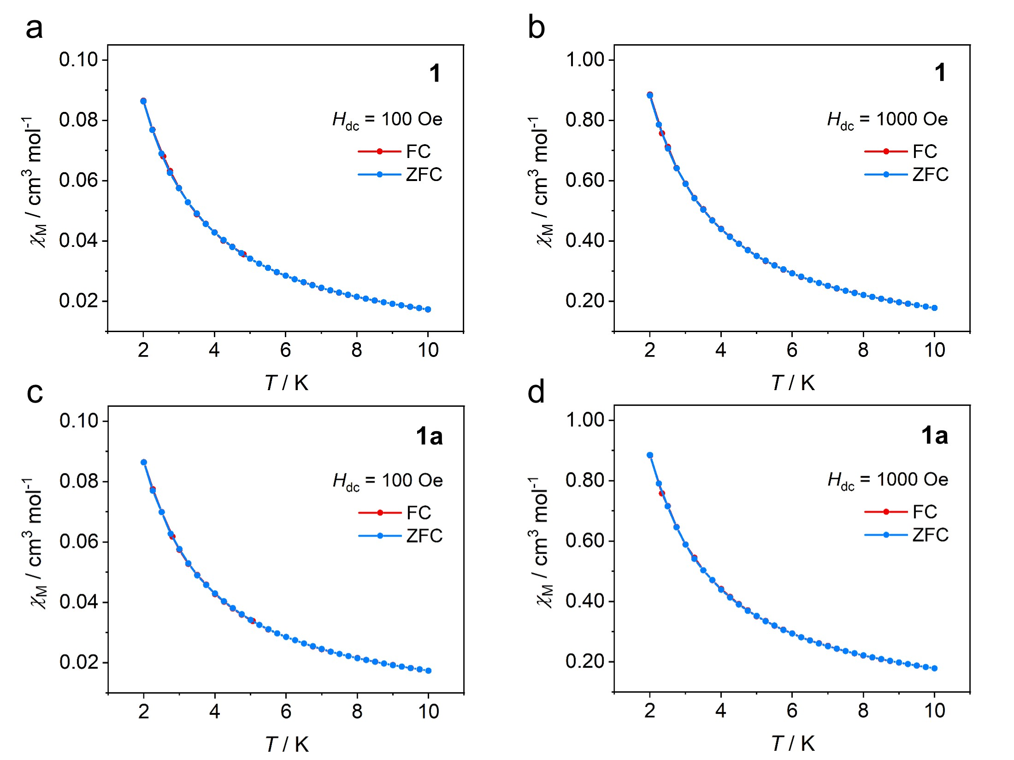
Figure S11. FC/ZFC magnetizations at 100 Oe and 1000 Oe for 1 (a, b) and 1a (c, d). The lines are guides for the eye.

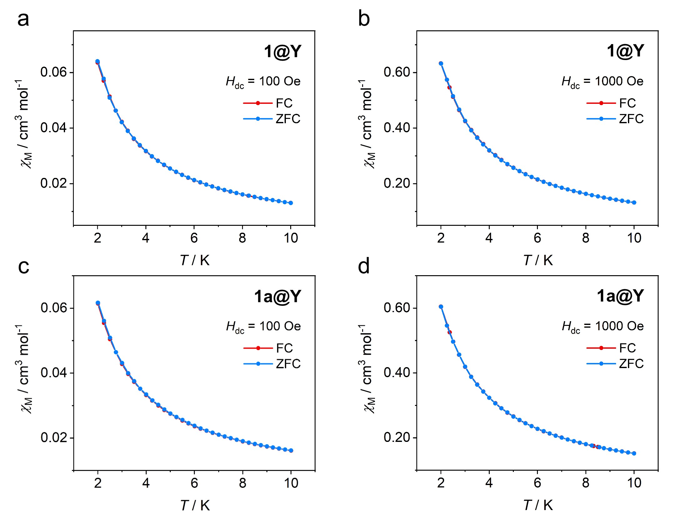
Figure S12. FC/ZFC magnetizations at 100 Oe and 1000 Oe for 1@Y (a, b) and 1a@Y (c, d). The lines are guides for the eye.

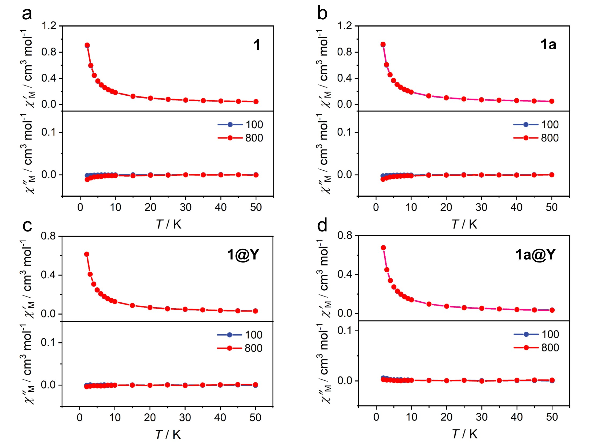
Figure S13. Temperature dependence of the χʹ and χʺ for 1 (a), 1a (b), 1@Y (c), 1a@Y (d), collected in zero dc field in the temperature range of 2−50 K, ν = 100, 800 Hz.

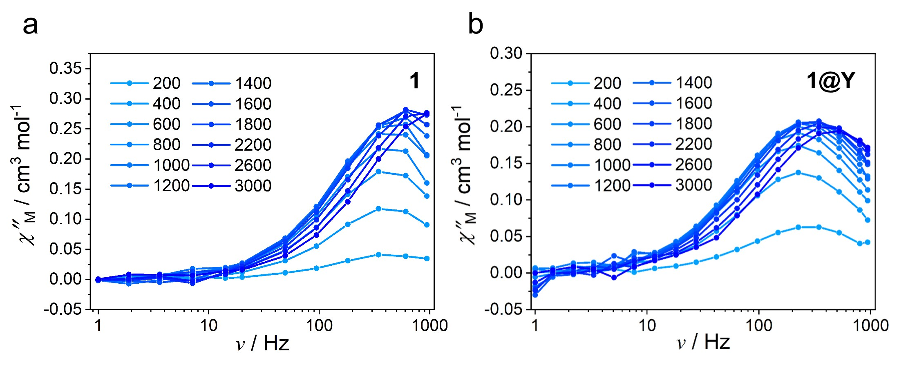
Figure S14. Frequency dependence of the χʺ at 2 K in various dc fields for 1 (a) and 1@Y (b).

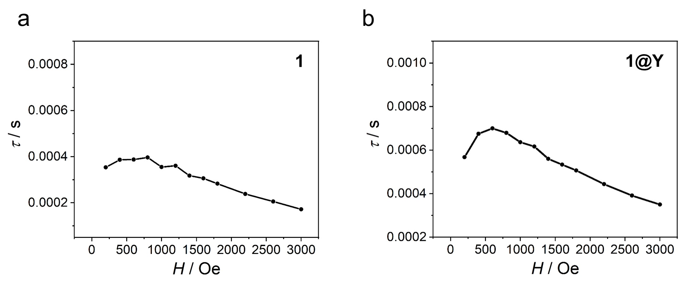
Figure S15. Field dependence of the magnetic relaxation time (τ) at 2 K for 1 (a) and 1@Y (b).

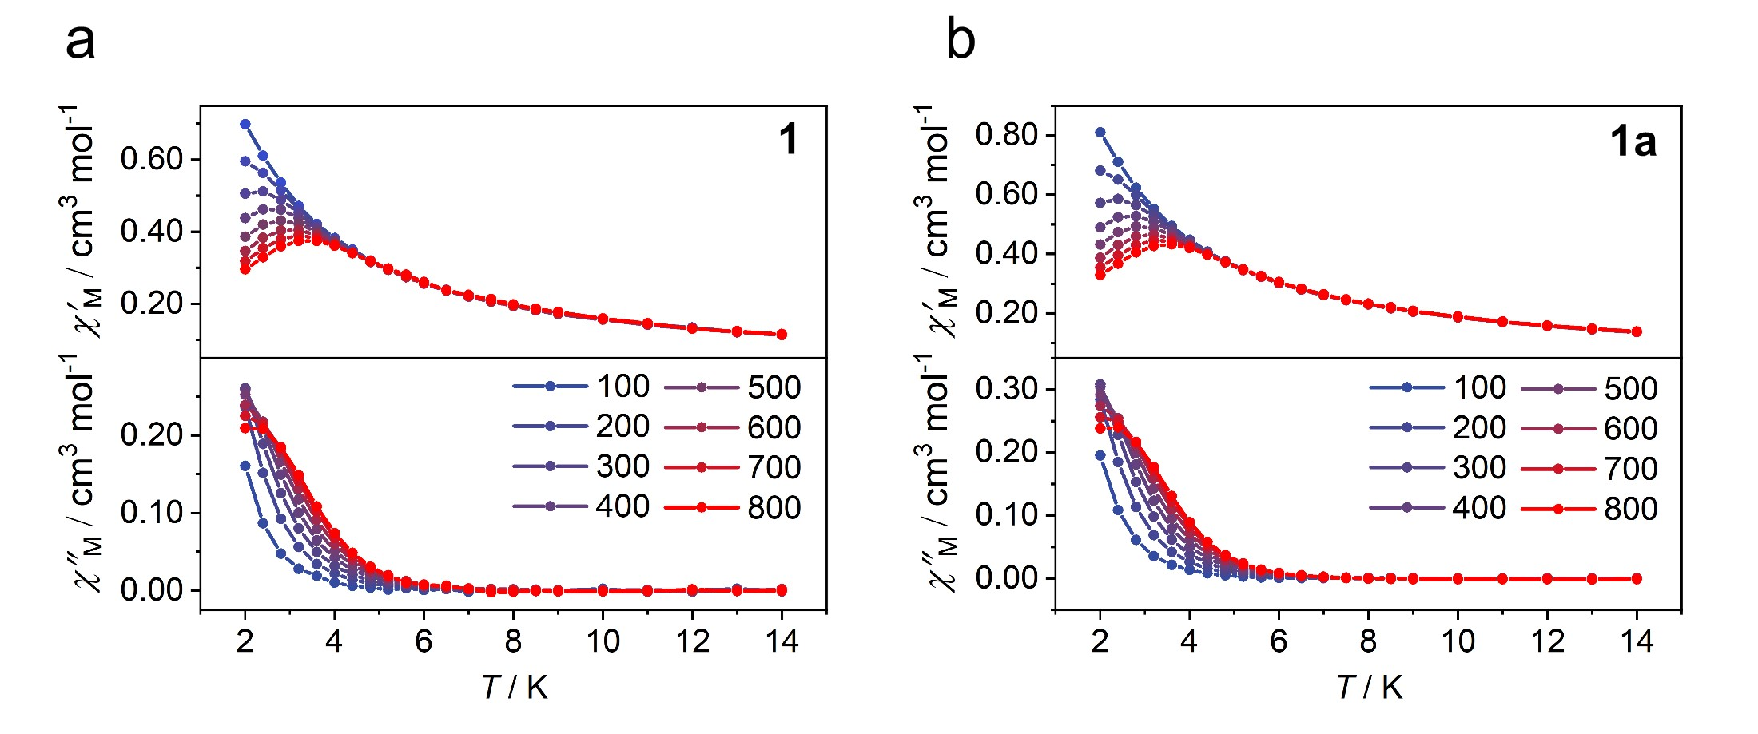
Figure S16. Temperature dependence of the in-phase χʹ and out-of-phase χʺ molar magnetic susceptibility for 1 and 1a, collected in 800 Oe dc field in the temperature range 2−14 K, ν = 100−800 Hz.

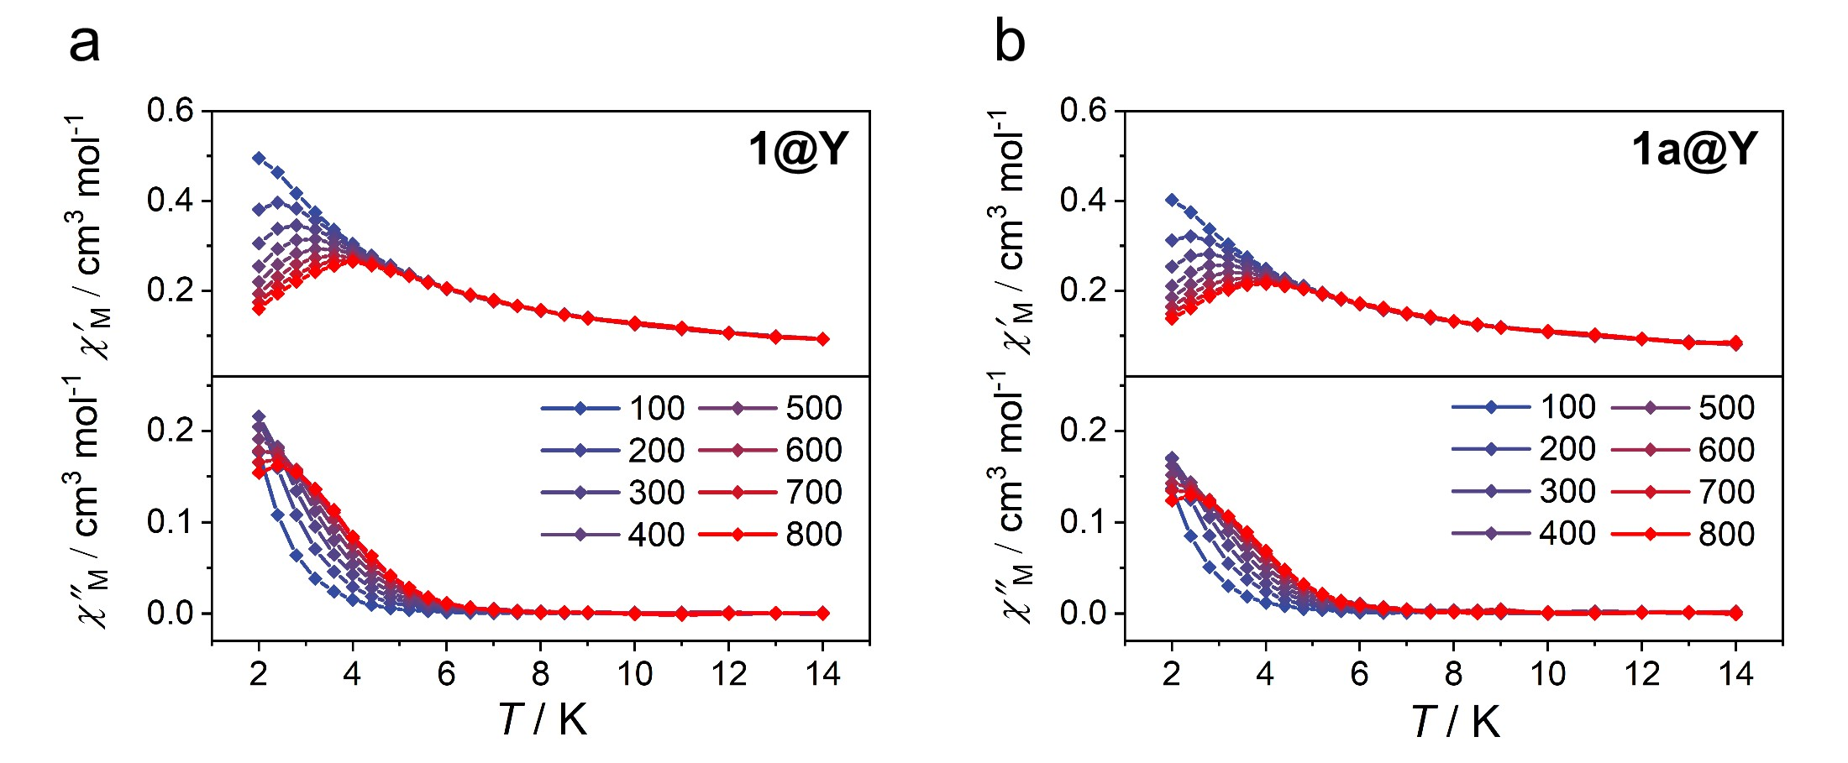
Figure S17. Temperature dependence of the in-phase χʹ and out-of-phase χʺ molar magnetic susceptibility for 1@Y and 1a@Y, collected in 600 Oe dc field in the temperature range 2−14 K, ν = 100−800 Hz.

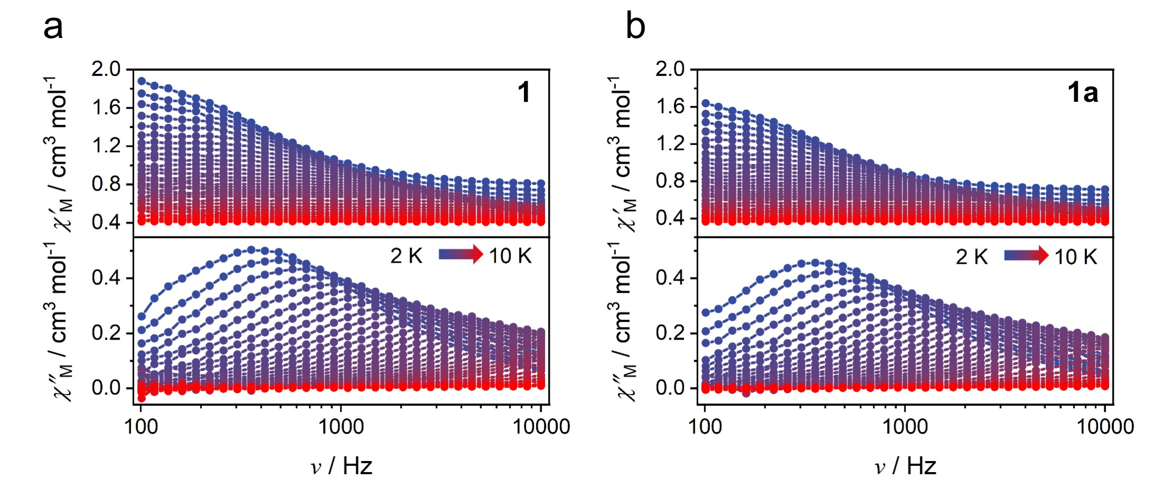
Figure S18. Frequency dependence of the in-phase χʹ and out-of-phase χʺ molar magnetic susceptibility for 1 and 1a, collected in 800 Oe dc field at ac frequencies of ν = 100 to 10000 Hz (PPMS).

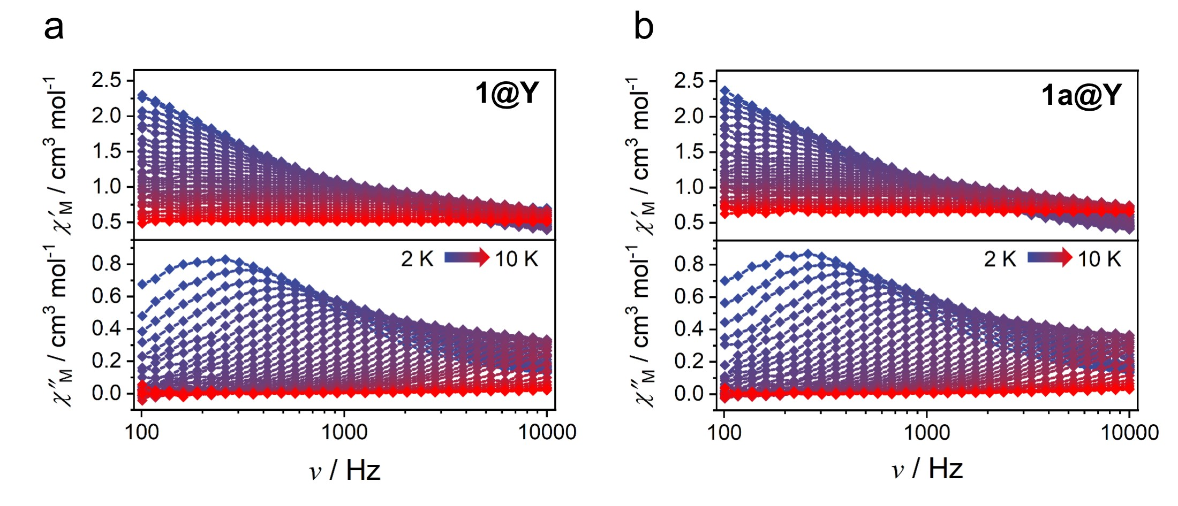
Figure S19. Frequency dependence of the in-phase χʹ and out-of-phase χʺ molar magnetic susceptibility for 1@Y and 1a@Y, collected in 600 Oe dc field at ac frequencies of ν = 100 to 10000 Hz (PPMS).

Table S1. Crystal data and structure refinement details for 1.
Compound | 1
CCDC | 2170113
Formula | C₂₄H₁₈Cl₂YbNO₈
Formula weight | 692.33
Temperature (K) | 298(2)
Crystal colour | Brown
Wavelength (Å) | 0.71073
Crystal system | Triclinic
Space group | P$\overline{\text{1}}$
a (Å) | 10.5301(5)
b (Å) | 11.1899(4)
c (Å) | 11.2384(7)
α (deg) | 84.757(4)
β (deg) | 68.300(5)
γ (deg) | 82.213(4)
Z | 2
V (Å³) | 1217.81(11)
ρ _{calc} (g/cm³) | 1.888
μ (mm⁻¹) | 4.109
F(000) | 674.0
R_{int} | 0.0503
Goodness-of-fit on F² | 0.967
ª R₁, ^{b} wR₂ (I ≥ 2σ(I)) | 0.0360, 0.0566
ª R₁, ^{b} wR₂ (all data) | 0.0518, 0.0608
ª${\text{R}}_{\text{1}}\text{=}\sum{\left|\left|{\text{F}}_{\text{o}}\right|\text{-}\left|{\text{F}}_{\text{c}}\right|\right|}\text{/}\sum{\left|{\text{F}}_{\text{o}}\right|}$, ^{b}${\text{ w}\text{R}}_{\text{2}}\text{=}\left|\sum{\text{w}\left({\left|{\text{F}}_{\text{o}}\right|}^{\text{2}}\text{-}{\left|{\text{F}}_{\text{c}}\right|}^{\text{2}}\right)}\right|\text{/}{\sum{\left|\text{w}{\left({\text{F}}_{\text{o}}\right)}^{\text{2}}\right|}}^{\text{1/2}}$

Table S2. Symmetries and deviated values of Yb(III) ion for 1 by SHAPE 2.0.
Shape | Symmetry | Deviated value
Octagon | D_{8h} | 28.805
Heptagonal pyramid | C_{7v} | 23.637
Hexagonal bipyramid | D_{6h} | 13.155
Cube | O_{h} | 8.025
Square antiprism | D_{4d} | 1.191
Triangular dodecahedron | D_{2d} | 2.197
Johnson gyrobifastigium J26 | D_{2d} | 12.362
The smaller the deviated value, the closer the local symmetry of a metal ion is to a specific symmetry.

Table S3. The increase of χ_{M}T values of photomagnetic complexes.
Complexes | The increase of χ_{M}T values | Ref.
(H₄-TIBP)_{0.5}·[Dy(H-HEDP) (H₂-HEDP)]·H₂O | –11.24% | 3
[Cu₄(HEDP)₂(TPA)₂]·2H₂O | +32% | 4
(H₃-TPB)[Fe(C₂O₄)₃]·H₂O | +3.95% | 5
[Tb₃(H-HEDP)₃(H₂-HEDP)₃]· 2H₃-TPT·H₄-HEDP·10H₂O | +6.66% | 6
[Dy₃(H-HEDP)₂(H₂-HEDP)₂(H₃-HEDP)₂]· H₃-TPP·11H₂O | –1.95% | 7
[Tb₃(H-HEDP)₂(H₂-HEDP)₂(H₃-HEDP)₂]· H₃-TPP·11H₂O | –5.34% | 7
[Dy^{III}(18C6)(H₂O)₃]Fe^{III}(CN)₆·2H₂O | +20.9% | 8
Cu₃(H-HEDP)₂TPT₂·2H₂O | –34.9% | 9
[Dy₃(H−HEDP)₃(H₂−HEDP)₃]·2H₃−TPT·H₄−HEDP·10H₂O | +3% | 10
Mn(H₂PO₄)(C₂O₄)_{0.5}(TPT)_{0.5}(H₂O) | –16.2% | 11
[MnCl₂(DMSO)₂(pz)]_{n} | +9.65% | 12
[FeCl₂(DMSO)₂(pz)]_{n} | +9.16% | 12
[CoCl₂(DMSO)₂(pz)]_{n} | +18.4% | 12
[Eu^{III}(18C6)(H₂O)₃]Fe^{III}(CN)₆·2H₂O | –33.5% | 13
[Yb(CA)(ACA)(DMF)(H₂O)]_{n} | +82.3% | This work
[Yb_{0.12}Y_{0.88}(CA)(ACA)(DMF)(H₂O)]_{n} | +88.9% | This work

Table S4. Magnetization relaxation fitting parameters for 1.
T | χ_{S} | χ_{T} | τ / s | α | Residual
2 | 0.79814 | 2.00405 | 4.03159E-4 | 0.11366 | 0.00223
2.2 | 0.72964 | 1.82522 | 3.14473E-4 | 0.10197 | 0.00118
2.4 | 0.6729 | 1.68379 | 2.52481E-4 | 0.09435 | 0.00209
2.6 | 0.62227 | 1.55379 | 2.01943E-4 | 0.08688 | 0.00131
2.8 | 0.58352 | 1.44002 | 1.64482E-4 | 0.07386 | 0.0015
3 | 0.54476 | 1.34214 | 1.34283E-4 | 0.06843 | 0.00225
3.4 | 0.48724 | 1.1892 | 9.28748E-5 | 0.05939 | 6.74517E-4
3.8 | 0.44468 | 1.06688 | 6.45851E-5 | 0.04688 | 0.00131
4.2 | 0.40791 | 0.96368 | 4.51529E-5 | 0.03774 | 5.7089E-4
4.6 | 0.38399 | 0.87648 | 3.19258E-5 | 0.02353 | 0.00135
5 | 0.35662 | 0.80726 | 2.25184E-5 | 0.02611 | 0.00113
5.4 | 0.32891 | 0.75092 | 1.57071E-5 | 0.0433 | 0.00532
5.8 | 0.33017 | 0.69603 | 1.18241E-5 | 0.02202 | 0.00188
6.2 | 0.30673 | 0.65269 | 8.18665E-6 | 0.04158 | 6.50141E-4
6.6 | 0.27405 | 0.61556 | 5.54515E-6 | 0.06168 | 7.50359E-4
7 | 0.21672 | 0.58134 | 3.24279E-6 | 0.09029 | 8.94591E-4
7.4 | 0.2172 | 0.55057 | 2.3928E-6 | 0.09923 | 4.64372E-4
7.6 | 0.07082 | 0.53964 | 1.36109E-6 | 0.18055 | 8.73066E-4
8 | 1.50699E-13 | 0.51315 | 7.8879E-7 | 0.23754 | 0.00159
8.4 | 3.10366E-13 | 0.48659 | 5.61699E-7 | 0.12055 | 0.00118
9 | 1.16764E-23 | 0.45545 | 3.54565E-7 | 0.14216 | 0.00119
9.2 | 1.04582E-23 | 0.4466 | 1.88878E-7 | 0.22551 | 0.00194
9.6 | 2.88345E-23 | 0.42939 | 1.20905E-7 | 0.26677 | 0.00188

Table S5. Magnetization relaxation fitting parameters for 1a.
T | χ_{S} | χ_{T} | τ / s | α | Residual
2 | 0.70527 | 1.74411 | 4.29323E-4 | 0.08219 | 6.7958E-4
2.2 | 0.64414 | 1.60348 | 3.40107E-4 | 0.07599 | 3.23536E-4
2.4 | 0.58835 | 1.47492 | 2.72031E-4 | 0.07308 | 4.84685E-4
2.6 | 0.54583 | 1.3615 | 2.17761E-4 | 0.06121 | 9.35099E-4
2.8 | 0.50877 | 1.27039 | 1.77354E-4 | 0.05952 | 8.94183E-4
3 | 0.47568 | 1.18454 | 1.47069E-4 | 0.0547 | 6.89816E-4
3.2 | 0.44643 | 1.10928 | 1.20445E-4 | 0.04877 | 8.30725E-4
3.4 | 0.42546 | 1.04391 | 1.00567E-4 | 0.0385 | 6.04604E-4
3.8 | 0.38797 | 0.94583 | 7.13534E-5 | 0.03065 | 6.9878E-4
4.2 | 0.35812 | 0.85911 | 4.93564E-5 | 0.02482 | 5.20768E-4
4.6 | 0.33046 | 0.7844 | 3.46638E-5 | 0.02427 | 2.94243E-4
5 | 0.31201 | 0.72084 | 2.45539E-5 | 0.01643 | 4.47416E-4
5.4 | 0.28995 | 0.66651 | 1.73456E-5 | 0.02224 | 2.56263E-4
5.8 | 0.2725 | 0.6259 | 1.21433E-5 | 0.03886 | 5.17296E-4
6.2 | 0.26183 | 0.58469 | 8.76502E-6 | 0.03429 | 3.799E-4
6.6 | 0.23442 | 0.55079 | 5.82697E-6 | 0.06089 | 3.02703E-4
7.2 | 0.19815 | 0.50912 | 3.15052E-6 | 0.09442 | 6.60428E-4
7.6 | 0.10163 | 0.48442 | 1.42927E-6 | 0.16056 | 3.64829E-4
8 | 7.39472E-8 | 0.46053 | 7.60977E-7 | 0.20288 | 5.67099E-4
8.4 | 1.41138E-7 | 0.43864 | 4.38996E-7 | 0.22894 | 1.41028E-4
8.8 | 3.57805E-7 | 0.41697 | 2.35891E-7 | 0.21573 | 3.04067E-4
9.4 | 8.48359E-7 | 0.39282 | 1.03061E-7 | 0.33916 | 5.75164E-4
9.6 | 1.79403E-6 | 0.38615 | 3.99313E-8 | 0.43925 | 1.82749E-4

Table S6. Magnetization relaxation fitting parameters for 1@Y.
T | χ_{S} | χ_{T} | τ / s | α | Residual
2 | 0.67645 | 2.82865 | 6.815E-4 | 0.17021 | 0.00893
2.2 | 0.62353 | 2.55083 | 4.96469E-4 | 0.14784 | 0.01763
2.4 | 0.56285 | 2.31832 | 3.90833E-4 | 0.14921 | 0.00651
2.6 | 0.51883 | 2.14374 | 3.16393E-4 | 0.1407 | 0.00648
2.8 | 0.48617 | 1.98539 | 2.55827E-4 | 0.12841 | 0.00583
3 | 0.45359 | 1.86748 | 2.17884E-4 | 0.12383 | 0.00676
3.4 | 0.40012 | 1.63239 | 1.54854E-4 | 0.10745 | 0.00466
3.8 | 0.36872 | 1.44576 | 1.11502E-4 | 0.07018 | 0.00578
4.2 | 0.33228 | 1.31332 | 8.02409E-5 | 0.06069 | 0.00455
4.6 | 0.29829 | 1.19599 | 5.67205E-5 | 0.05502 | 0.00168
5 | 0.27886 | 1.09808 | 3.97042E-5 | 0.03826 | 0.00495
5.4 | 0.25664 | 1.02175 | 2.72541E-5 | 0.02986 | 0.00208
5.8 | 0.25369 | 0.94844 | 1.94361E-5 | 0.0082 | 0.00482
6.2 | 0.2196 | 0.88531 | 1.32856E-5 | 0.01481 | 0.002
6.6 | 0.21634 | 0.83282 | 9.69082E-6 | 0.01725 | 0.00171
7 | 0.15816 | 0.77285 | 6.5966E-6 | 0.04402 | 0.00301
7.6 | 0.11836 | 0.71486 | 3.94711E-6 | 0.04934 | 0.00214
8.2 | 0.23794 | 0.644 | 3.01787E-6 | 2.06886E-7 | 0.00238
8.8 | 0.11915 | 0.59551 | 1.94601E-6 | 7.14948E-7 | 0.0031
9.6 | 0.08444 | 0.53022 | 1.17513E-6 | 2.69212E-8 | 0.00635

Table S7. Magnetization relaxation fitting parameters for 1a@Y.
T | χ_{S} | χ_{T} | τ / s | α | Residual
2 | 0.644 | 2.87031 | 6.65329E-4 | 0.1627 | 0.01236
2.2 | 0.59029 | 2.62941 | 4.98093E-4 | 0.15989 | 0.00749
2.4 | 0.55532 | 2.44554 | 3.91332E-4 | 0.15095 | 0.0065
2.6 | 0.5207 | 2.25684 | 3.08608E-4 | 0.13592 | 0.00712
2.8 | 0.48553 | 2.1242 | 2.58824E-4 | 0.13284 | 0.00596
3 | 0.46632 | 1.96166 | 2.09882E-4 | 0.10986 | 0.02192
3.4 | 0.41307 | 1.73896 | 1.54008E-4 | 0.09987 | 0.00626
3.8 | 0.36537 | 1.52571 | 1.09335E-4 | 0.07888 | 0.00958
4.2 | 0.33482 | 1.38806 | 7.99941E-5 | 0.06574 | 0.00278
4.6 | 0.3146 | 1.26856 | 5.61004E-5 | 0.0425 | 0.00323
5 | 0.2943 | 1.17164 | 3.96346E-5 | 0.03014 | 0.00234
5.4 | 0.27077 | 1.09349 | 2.76401E-5 | 0.03331 | 0.00335
5.8 | 0.26155 | 1.02976 | 1.93954E-5 | 0.02296 | 7.12195E-4
6.2 | 0.23488 | 0.97543 | 1.33743E-5 | 0.03687 | 0.00428
6.6 | 0.20042 | 0.91546 | 9.15278E-6 | 0.05253 | 0.00301
7 | 0.17539 | 0.85708 | 6.47282E-6 | 0.04449 | 7.22672E-4
7.6 | 0.11594 | 0.79369 | 3.49316E-6 | 0.08844 | 8.36793E-4
8.2 | 0.12082 | 0.75975 | 2.50184E-6 | 0.05404 | 0.00157
8.8 | 6.52138E-8 | 0.71711 | 1.08417E-6 | 0.14016 | 9.19597E-4
9.6 | 1.99882E-7 | 0.69359 | 5.20103E-7 | 0.22416 | 0.00462

Table S8. Comparison of AC magnetic data of Yb(III) coordination compounds.
compounds | type | CShM | H_{dc}  (Oe) | U_{eff}  (K) | τ₀  (s) | B  (s^{–1} K^{–1}) | A  (s^{–1} K^{–n}) | n | τ_{QTM}  (s) | Ref.
[Yb(H₃L)₂]Cl₃·5CH₃OH·2H₂O | mononuclear | O_{h}  0.350 | 400 | 7 | 2 × 10⁻⁵ |  |  |  |  | 14
[YbZn₄(quinha)₄(iqn)₄(DMF)₄]  (CF₃SO₃)₃·6DMF·4H₂O | mononuclear | D_{4d}  0.136 | 600 | 23 | 4 × 10⁻⁷ |  |  |  |  | 15
[Yb(Tpz)₂Bpz]·CH₂Cl₂ | mononuclear | D_{3h}  1.103 | 1500 | 29 | 2 × 10⁻⁸ |  |  |  |  | 16
[Ln(L)₂(tta)(CH₃OH)]·CH₃OH | mononuclear | C_{4v}  0.730 | 1000 | 30 | 2 × 10⁻⁷ |  | 0.3 | 6.5 |  | 17
[Yb(H₃L^{1,1,4})]·2MeOH | mononuclear | C_{2v}  2.974 | 1600 |  |  | 1016 | 8.7 | 4.9 |  | 18
[Yb(Tpma)(NO₃)₃] | mononuclear | C_{s}  2.067 | 1000 |  |  | 717 | 98 | 3.9 |  | 19
[¹⁷³Yb_{0.07}Y_{0.93}(tta)₃(L)]·C₆H₁₄ | mononuclear | D_{4d}  0.440 | 0 | 33 | 7 × 10⁻⁸ |  | 220 | 1.6 | 3.2 × 10⁻⁵ | 20
Yb(III)[{N(SiMePh₂)₂}₂][Al{OC(CF₃)₃}₄] | mononuclear | C_{2v}  – | 1600 |  |  |  | 0.528 | 6.3 | 98.4 | 21
[Yb₂L₂(acac)₂(H₂O)]·2CH₂Cl₂ | dinuclear | D_{4d} (Yb1)  C_{2v} (Yb2) | 1600 | 25 | 7 × 10⁻⁷ |  |  |  |  | 22
[Yb(tta)₂(L¹)(L²)]₂·1.4(CH₂Cl₂) | dinuclear | D_{2d}  – | 2000 | 20 | 2 × 10⁻⁶ |  |  |  |  | 23
[Zn(μ-L)(μ-NO₃)Yb(NO₃)₂] | dinuclear 3d-4f | C_{4v}  1.450 | 1000 | 27 | 9 × 10⁻⁷ |  |  |  |  | 24
[Yb₂(valdien)₂(NO₃)₂] | dinuclear | – | 1000 | 66 | 5 × 10⁻⁸ |  | 0.097 | 6.0 | 2.2 × 10⁻² | 25
[Yb₂(5-Me-L)₂(DMF)₂(NO₃)₂]·DMF | dinuclear | C_{2v}  3.354 | 1200 | 77 | 2 × 10⁻⁹ |  | 15.3 | 2.9 |  | 26
[Yb₂(3-OMe-L)₂(DMF)₂(NO₃]·DMF | dinuclear | D_{2d}  2.960 | 1200 | 50 | 2 × 10⁻⁸ |  |  |  |  | 27
[Yb₂(3-H-L)₂(DMF)₂(NO₃]·DMF·H₂O | dinuclear | C_{2v}  3.271 | 1000 | 47 | 4 × 10⁻⁸ |  |  |  |  | 27
[Yb₂(3-NO₃-L)₂(DMF)₂(NO₃] | dinuclear | D_{2d}  1.910 | 1000 | 40 | 9 × 10⁻⁸ |  |  |  |  | 27
Na₉[Yb(W₅O₁₈)₂]·35H₂O | Polyoxometalate | D_{4d}  0.063 | 1200 | 47 | 7 × 10⁻⁸ |  | 85 | 1.8 |  | 28
[YbCo(CN)₆(bpyO₂)₂(H₂O)₃]·4H₂O | 3d-4f | D_{2d}  0.929 | 1250 |  |  |  | 0.036 | 7.2 |  | 29
{[Yb(3-pyridone)₂(H₂O)₂][Co(CN)₆]} | 1D chain | O_{h}  0.114 | 1000 | 45 | 3 × 10⁻⁷ |  |  |  |  | 30
(PPN)[Yb(pzdo)₂(MeOH)_{0.3}(H₂O)_{3.7}]  [Mo(CN)₈]·7.7H₂O·2MeOH | 1D chain | D_{2d}  0.731 | 1000 |  |  |  | 1.3 | 5.1 |  | 31
(PPN)[Yb(pzdo)₂(MeOH)_{0.3}(H₂O)_{3.7}]  [W(CN)₈]·7.7H₂O·2MeOH | 1D chain | D_{2d}  0.772 | 1000 |  |  |  | 0.56 | 6.0 |  | 31
[NH₄][Yb(HMBA)₄] | 1D chain | C_{2v}  1.648 | 2500 | 29 | 1 × 10⁻⁷ |  |  |  | 5.7 × 10⁻³ | 32
[Yb(tpa)(H₂O)₂Co(CN)₆]_{n}·7nH₂O | 1D chain | – | 1000 | 42 | 8 × 10⁻⁸ |  | 1.48 | 4.6 |  | 33
{[Yb(cpbOH)(H₂O)₂](cpb)}∞ | 2D network | – | 1600 | 7 | 3 × 10⁻⁵ |  |  |  |  | 34
{[Yb₅L₆(OH)₃(DMF)₃]·5H₂O}_{n} | 3D network | – | 1000 |  |  |  | 0.56 | 6.8 | 6.8 × 10⁻⁵ | 35
1 | 2D network  dinuclear | D_{4d}  1.191 | 800 | 94 | 8 × 10⁻¹² |  | 232 | 3.2 |  | This work
1a | 2D network  dinuclear | – | 800 | 111 | 9 × 10⁻¹³ |  | 199 | 3.3 |  | This work
1@Y | 2D network  dinuclear | – | 600 |  |  |  | A = 323  C = 0.56 | n = 2.3  m = 6.3 |  | This work
1a@Y | 2D network  dinuclear | – | 600 |  |  |  | A = 225  C = 0.0054 | n = 2.8  m = 8.6 |  | This work
Table S9. Ab initio energy structure for the ground multiplets of the Yb sites in 1 and 1a.
 | Basis MB |  | Basis VDZP |  | Basis VTZP
 | Energy (cm⁻¹) | Main values of the g-tensor | Energy (cm⁻¹) | Main values of the g-tensor | Energy (cm⁻¹) | Main values of the g-tensor
J=7/2 | 0.0  0.0 | g_{X} = 1.06897  g_{Y} = 1.58563  g_{Z} = 5.43841 | 0.0  0.0 | g_{X} = 0.61442  g_{Y} = 0.97557  g_{Z} = 7.43373 | 0.0  0.0 | g_{X} = 0.62243  g_{Y} = 0.97443  g_{Z} = 7.36296
J=7/2 | 160.5  160.5 | g_{X} = 0.00805  g_{Y} = 0.31070  g_{Z} = 7.30739 | 156.8  156.8 | g_{X} = 0.27125  g_{Y} = 0.50841  g_{Z} = 7.24489 | 193.2  193.2 | g_{X} = 0.42991  g_{Y} = 0.56797  g_{Z} = 7.32537
J=7/2 | 297.0  297.0 | g_{X} = 1.45374  g_{Y} = 2.77891  g_{Z} = 4.93796 | 328.2  328.2 | g_{X} = 2.09447  g_{Y} = 2.28868  g_{Z} = 5.33424 | 327.9  327.9 | g_{X} = 2.04375  g_{Y} = 2.19707  g_{Z} = 5.41177
J=7/2 | 412.7  412.7 | g_{X} = 0.10741  g_{Y} = 0.70205  g_{Z} = 6.97976 | 477.2  477.2 | g_{X} = 0.19040  g_{Y} = 0.30903  g_{Z} = 7.67632 | 476.6  476.6 | g_{X} = 0.23922  g_{Y} = 0.36326  g_{Z} = 7.65440
J=5/2 | 9833.4  9833.4 | g_{X} = 2.37994  g_{Y} = 1.62631  g_{Z} = 0.14095 | 10486.6  10486.6 | g_{X} = 0.29914  g_{Y} = 0.42118  g_{Z} = 4.12375 | 10348.1  10348.1 | g_{X} = 0.23922  g_{Y} = 0.36326  g_{Z} = 7.65440
J=5/2 | 9906.8  9906.8 | g_{X} = 0.81117  g_{Y} = 1.62907  g_{Z} = 2.95933 | 10654.7  10654.7 | g_{X} = 0.58824  g_{Y} = 1.47405  g_{Z} = 2.95135 | 10527.9  10527.9 | g_{X} = 0.61806  g_{Y} = 1.37981  g_{Z} = 3.20629
J=5/2 | 10156.5  10156.5 | g_{X} = 0.75601  gY = 1.60648  gZ = 3.16518 | 10886.5  10886.5 | g_{X} = 0.69119  g_{Y} = 1.33427  g_{Z} = 3.59156 | 10738.7  10738.7 | g_{X} = 0.68791  g_{Y} = 1.29457  g_{Z} = 3.61145

Table S10. Crystal field parameters the ground J=7/2 multiplet. The quantization axis is the original cartesian Z axis.
Rank | Projection | Basis MB | Basis VDZP | Basis VTZP
2 | -2  -1  0  +1  +2 | -10.08760  8.37300  0.95572  1.89083  3.24007 | -14.79460  22.19230  -2.57777  11.62960  1.05040 | -13.35710  21.30670  -3.28232  12.19680  -0.50283
4 | -4  -3  -2  -1  0  +1  +2  +3  +4 | -0.29701  1.15042  -0.13060  0.48654  0.01018  0.50930  -0.03787  2.38570  -0.30957 | -0.18393  0.84547  -0.07996  0.34057  -0.01357  0.38219  -0.01727  1.45399  -0.29778 | -0.18708  0.90995  -0.09122  0.37445  -0.01274  0.42688  -0.02761  1.52537  -0.31242
6 | -6  -5  -4  -3  -2  -1  0  +1  +2  +3  +4  +5  +6 | 0.01498  0.15468  -0.01626  -0.00991  -0.00728  -0.01004  0.00207  -0.01747  0.02212  0.00463  0.00150  0.05851  0.04233 | 0.01072  0.10723  -0.01005  -0.00516  -0.00467  -0.00615  0.00183  -0.00881  0.01334  -0.00029  0.00161  0.04842  0.02543 | 0.01158  0.10713  -0.00871  -0.00664  -0.00390  -0.00774  0.00178  -0.00989  0.01354  -0.00197  0.00213  0.04067  0.02700

Table S11. Magnetic exchange values for two different exchange paths and several DFT functionals.
DFT functional | Yb₂ path 1 | Yb₂ path 2
LC-PBE | -0.01 | -0.01
PBE | -0.05 | -0.02
M062X | -0.01 | 0.00

Table S12. The energy gap between the ground state singlet S₀ and the excited states S₁, T₁, and T₂ for each ligand.
Gap (eV)
 | Original structure |  | Embedded
 | ACA– | CA^{2–} | 3 Ligands | Ligand 2
S₀ - S₁ | 2.325 | 3.002 | 2.177 | 2.888
S₀ - T₁ | 1.792 | 2.001 | 1.806 | 1.863
S₀ - T₂ | 2.493 | 2.631 | 2.116 | 2.479
T₀ - T₁ | 1.092 | 0.674 | 0.332 | 0.971

Table S13. Phosphorescence rate of the two ligands. Note that the relaxation of the CA^{2–} ligand is much faster than of ACA– ligand.
Phosphorescence rate constant (s^{–1})
 | ACA– | CA^{2–}
T₁ | 1.54714E-03 | 4.40951E-01
T₂ | 2.85037E-03 | 4.40003E-03
T₃ | 1.08538E-03 | 1.23963E+00
Average | 1.82763E-03 | 5.61659E-01

References
- O. Kahn, Molecular Magnetism, VCH Publishers, New York, 1993.
- G. M. Sheldrick, A short history of shelx, Acta Crystallogr. A 2008, 64, 112.
- G.-M. Li, F. Xu, S.-D. Han, J. Pan and G.-M. Wang, Hybrid photochromic lanthanide phosphonate with multiple photoresponsive functionalities, Inorg. Chem., 2022, 61, 8379.
- Z.-N. Gao, D.-X. Feng, Y. Wang, F.-H. Li, H.-Y. Sun, J.-X. Hu and G.-M. Wang, Large room temperature magnetization enhancement in a copperbased photoactive metal-organic framework, Inorg. Chem., 2022, 61,15812.
- D.-X. Feng, W.-J. Wei, Q. Li, Q. Zhang, J.-X. Hu, G.-M. Wang and J.-H. Li, From weak to strong antiferromagnetism: tuning the magnetic properties of a mononuclear Fe³⁺ complex via electron transfer photochromism, Cryst. Growth Des., 2022, 22, 5441.
- Q. Zhang, W.-J. Wei, Q. Li, J. Pan, S.-De Han, J.-X. Hu and G.-M. Wang, Light enhanced proton conductivity in a terbium phosphonate photochromic chain complex. Sci. China Chem., 2021, 64, 1170.
- Q. Zhang, S.-D. Han, Q. Li, J.-X. Hu and G.-M. Wang, Electron transfer photochromism of Ln-based (Ln = Dy, Tb) coordinated polymers for reversibly switching off/on single-molecule magnetic behavior, Sci. China Mater., 2022, 65, 788.
- L.-Z. Cai, P.-Y. Guo, M.-S. Wang and G.-C. Guo, Photoinduced magnetic phase transition and remarkable enhancement of magnetization for a photochromic single-molecule magnet, J. Mater. Chem. C, 2021, 9, 2231.
- J.-X. Hu, X.-F. Jiang, Y.-J. Ma, X.-R. Liu, B.-D. Ge, A.-N. Wang, Q. Wei and G.-M. Wang, Optically actuating ultra-stable radicals in a large π-conjugated ligand constructed photochromic complex, Sci. China Chem., 2021, 64, 432.
- Y.-J. Ma, J.-X. Hu, S.-D. Han, J. Pan, J.-H. Li, and G.-M. Wang, Manipulating On/Off single-molecule magnet behavior in a Dy(III)-based photochromic complex, J. Am. Chem. Soc., 2020, 142, 2682.
- Y.-J. Ma, J.-X. Hu, S.-D. Han, J. Pan, J.-H. Li and G.-M. Wang, Photochromism and photomagnetism in crystalline hybrid materials actuated by nonphotochromic units, Chem. Commun., 2019, 55, 5631.
- B. Xia, Y. Zhou, Q.-L. Wang, X.-F. Xu, Y.-Z. Tong, X.-H. Bu and J.-R. Li, Photoinduced electron transfer and remarkable enhancement of magnetic susceptibility in bridging pyrazine complexes, Dalton Trans., 2018, 47,15888.
- L.-Z. Cai, Q.-S. Chen, C.-J. Zhang, P.-X. Li, M.-S. Wang and G.-C. Guo, Photochromism and photomagnetism of a 3d−4f hexacyanoferrate at room temperature, J. Am. Chem. Soc., 2015, 137, 10882.
- J. L. Liu, K. Yuan, J. D. Leng, L. Ungur, W. Wernsdorfer, F. S. Guo, L. F. Chibotaru and M. L. Tong, A six-coordinate ytterbium complex exhibiting easy-plane anisotropy and field-induced single-ion magnet behavior, Inorg. Chem., 2012, 51, 8538.
- Q.-W. Li, J.-L. Liu, J.-H. Jia, Y.-C. Chen, J. Liu, L.-F. Wang and M.-L. Tong, "Half-Sandwich" Yb(III) single-ion magnets with metallacrowns, Chem. Commun., 2015, 51, 10291.
- A. Lannes and D. Luneau, New family of lanthanide-based complexes with different scorpionate-type ligands: a rare case where dysprosium and ytterbium analogues display single-ion-magnet behavior, Inorg. Chem., 2015, 54, 6736.
- J. R. Jimenez, I. F. Diaz-Ortega, E. Ruiz, D. Aravena, S. J. Pope, E. Colacio and J. M. Herrera, Lanthanide tetrazolate complexes combining single-molecule magnet and luminescence properties: the effect of the replacement of tetrazolate N₃ by beta-diketonate ligands on the anisotropy energy barrier, Chem.–Eur. J., 2016, 22, 14548.
- M. Fondo, J. Corredoira-Vázquez, A. M. García-Deibe, J. Sanmartín-Matalobos, M. Amoza, A. M. P. Botas, R. A. S. Ferreira, L. D. Carlos and E. Colacio, Field-induced slow magnetic relaxation and luminescence thermometry in a mononuclear ytterbium complex, Inorg. Chem. Front., 2020, 7, 3019.
- J. Long, D. M. Lyubov, T. V. Mahrova, K. A. Lyssenko, A. A. Korlyukov, Y. V. Fedorov, E. Y. Chernikova, Y. Guari, J. Larionova and A. A. Trifonov, Heteroleptic lanthanide complexes coordinated by tripodal tetradentate ligand: synthesis, structure, and magnetic and photoluminescent properties, Cryst. Growth Des., 2020, 20, 5184.
- J. F. Gonzalez, H. Douib, B. Le Guennic, F. Pointillart and O. Cador, Ytterbium-centered isotopic enrichment leading to a zero-field single-molecule magnet, Inorg. Chem., 2021, 60, 540.
- D. Errulat, K. L. M. Harriman, D. A. Galico, A. A. Kitos, A. Mansikkamaki and M. Murugesu, A trivalent 4f complex with two bis-silylamide ligands displaying slow magnetic relaxation, Nat. chem., 2023, 15, 1100.
- P. H. Lin, W. B. Sun, Y. M. Tian, P. F. Yan, L. Ungur, L. F. Chibotaru and M. Murugesu, Ytterbium can relax slowly too: a field-induced Yb₂ single-molecule magnet, Dalton Trans., 2012, 41, 12349.
- F. Pointillart, B. Le Guennic, S. Golhen, O. Cador, O. Maury and L. Ouahab, A redox-active luminescent ytterbium based single molecule magnet, Chem. Commun., 2013, 49, 615.
- J. Ruiz, G. Lorusso, M. Evangelisti, E. K. Brechin, S. J. Pope and E. Colacio, Closely-related Zn(II)₂ln(III)₂ complexes (Ln(III) = Gd, Yb) with either magnetic refrigerant or luminescent single-molecule magnet properties, Inorg. Chem., 2014, 53, 3586.
- G. Brunet, R. Marin, M. J. Monk, U. Resch-Genger, D. A. Galico, F. A. Sigoli, E. A. Suturina, E. Hemmer and M. Murugesu, Exploring the dual functionality of an ytterbium complex for luminescence thermometry and slow magnetic relaxation, Chem. Sci., 2019, 10, 6799.
- A. Mondal and S. Konar, A remarkable energy barrier for spin reversal in a field induced dinuclear ytterbium single molecule magnet, Dalton Trans., 2021, 50, 13666.
- A. Mondal and S. Konar, Strong equatorial crystal field enhances the axial anisotropy and energy barrier for spin reversal process in Yb₂ single molecule magnets, Chem.–Eur. J., 2021, 27, 3449.
- O. Y. Mariichak, S. Kaabel, Y. A. Karpichev, G. M. Rozantsev, S. V. Radio, C. Pichon, H. Bolvin and J.-P. Sutter, Crystal structure and magnetic properties of peacock-weakley type polyoxometalates Na₉[Ln(W₅O₁₈)₂] (Ln = Tm, Yb): rare example of Tm(III) SMM, Magnetochemistry 2020, 6, 53.
- K. Karachousos-Spiliotakopoulos, V. Tangoulis, N. Panagiotou, A. Tasiopoulos, E. Moreno-Pineda, W. Wernsdorfer, M. Schulze, A. M. P. Botas and L. D. Carlos, Luminescence thermometry and field induced slow magnetic relaxation based on a near infrared emissive heterometallic complex, Dalton. Trans., 2022, 51, 8208.
- S. Chorazy, M. Rams, J. Wang, B. Sieklucka and S. I. Ohkoshi, Octahedral Yb(III) complexes embedded in [Co(III)(CN)₆]-bridged coordination chains: combining sensitized near-infrared fluorescence with slow magnetic relaxation, Dalton Trans., 2017, 46, 13668.
- R. Jankowski, J. J. Zakrzewski, O. Surma, S.-I. Ohkoshi, S. Chorazy and B. Sieklucka, Near-infrared emissive Er(III) and Yb(III) molecular nanomagnets in metal-organic chains functionalized by octacyanidometallates(IV), Inorg. Chem. Front., 2019, 6, 2423.
- W.-B. Chen, L. Zhong, Y.-J. Zhong, Y.-Q. Zhang, S. Gao and W. Dong, Understanding the near-infrared fluorescence and field-induced single-molecule-magnetic properties of dinuclear and one-dimensional-chain ytterbium complexes based on 2-hydroxy-3-methoxybenzoic acid, Inorg. Chem. Front., 2020, 7, 3136.
- S. P. Petrosyants, A. B. Ilyukhin, K. A. Babeshkin, N. N. Efimov and P. S. Koroteev, New chain polymer [Yb(tpa)(H₂O)₂Co(CN)₆]_{n}·7nH₂O: synthesis, structure, and magnetic characteristics, Mendeleev Commun., 2023, 33, 45.
- X. Fan, S. Freslon, C. Daiguebonne, L. Le Pollès, G. Calvez, K. Bernot, X. Yi, G. Huang and O. Guillou, A family of lanthanide-based coordination polymers with boronic acid as ligand, Inorg. Chem., 2015, 54, 5534.
- E. Echenique-Errandonea, R. F. Mendes, F. Figueira, D. Choquesillo-Lazarte, G. Beobide, J. Cepeda, D. Ananias, A. Rodriguez-Dieguez, F. A. Almeida Paz and J. M. Seco, Multifunctional lanthanide-based metal-organic frameworks derived from 3-amino-4-hydroxybenzoate: single-molecule magnet behavior, luminescent properties for thermometry, and CO₂ adsorptive capacity, Inorg. Chem., 2022, 61, 12977.

